When was it best to live in …?

‘Seedy at times, grim in places, but colourful and tinted with the hues of history’

This was cricket commentator and author John Arlott’s comment on Portsmouth in 1969. On a visit in 1729, Steven Martin Leake described Portsmouth Point as Gomorrah, pairing it with the notorious Gallows Point in Jamaica, which had a reputation for being like Sodom. It is a fascinating city, with a rich and diverse past that has played a pivotal part in the nation’s history. Did you know that Portsmouth was excommunicated in 1449? Or that the Danes devastated Portsea Island 979? Few do. For myself, local history is a passion that started with stories from my grandad about my family, then working for the museum service in the city and also writing two dissertations on the history of Portsmouth. I’ve always wanted to get the ‘big picture’ of Portsmouth’s history across to our learners and my experience with the Challenge Group allowed it to happen.

In December 2014 I attended the first of three sessions for the Challenge Group. These sessions are intended to challenge teachers in their second and third years of teaching to create engaging, original and outstanding lessons. The focus of our sessions, presented to us by Sarah Herrity and Neil Bates, was to create a lesson that catered for the ‘study of an aspect or theme in British history that consolidates and extends pupils’ chronological knowledge from before 1066’. Sarah and Neil presented some example lessons and we also discussed the various approaches we could take in our planning. Would it be national, international or local? A transition project? A theme running through KS3? There were many aspects to consider but there was one thing we all agreed that our lessons would be, and that is enquiry led. When Sarah showed the group a lesson titled ‘When was it best to live in Southampton?’, the local rivalry immediately kicked in. I thought Portsmouth deserves a lesson like that, so from that moment I knew my approach would be local. The enquiry I created was ‘When was it best to live in Portsmouth?’

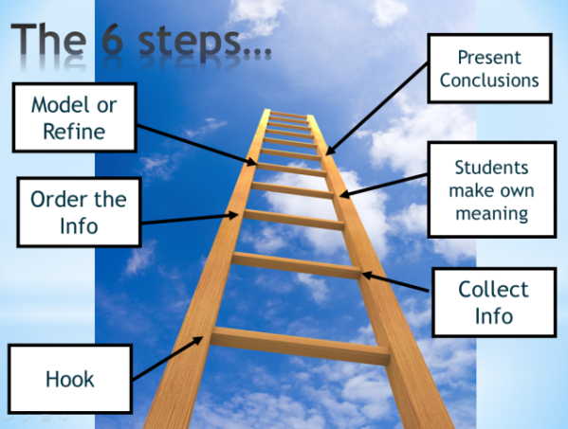
Planning, reflecting and editing
When planning the lesson for the first time I found it a difficult process, especially when I decided to have the enquiry stretch from the Roman period to the Nineteenth Century. Any teacher can understand the frustration when you know so much about a topic and you have to make the difficult decision of what stays in the lesson and what is left out. It was also clear that although I had an abundance of evidence to use in some periods, there was also a lack of evidence for others. I decided not to limit the time scale but instead allow pupils to understand that sometimes there is not sufficient evidence to make a judgment. I also structured the lesson according the Hampshire History Steering Group’s six step approach to enquiry. I would use a mural from 1874 of the Battle of Southsea and a famous eighteenth century painting of Portsmouth Point as my ‘hook’, then pupils would carousel around the information stations to collect the information. After these stages pupils would rate the time periods 1-7 and then refine their results on a living graph and present their conclusions to the class.

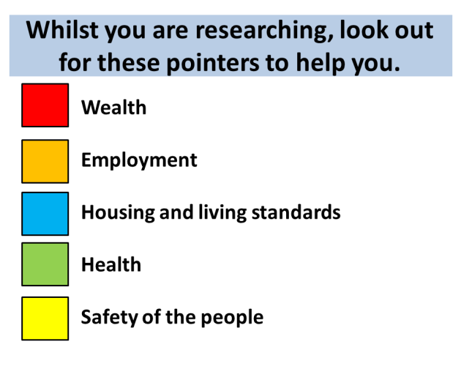
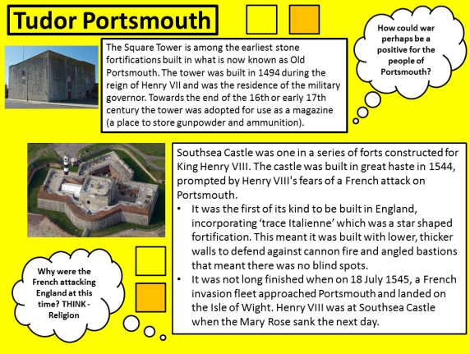
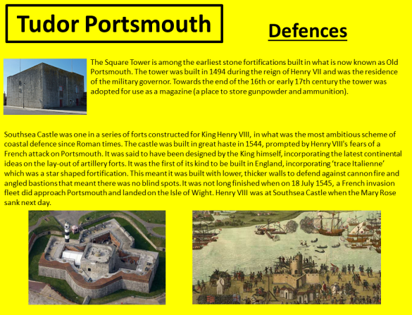
I had most of the lesson made by the time I attended the second session of the Challenge Group in January 2015. This meeting was a valuable part of the process in creating our lessons and a learning curve for any teacher at the beginning of their career. It was at this meeting that our lessons were refined and elevated from good to outstanding. We each presented our lessons and then the group critiqued them. Seeing the varied ways each teacher had planned their lesson was interesting enough; some had powerpoints and step by step guides, some had just initial thoughts in the form of a lesson plan and others had elaborate mind maps of what will be included in their lesson. The critiquing of my lesson by other young teachers and experienced practitioners, such as Sarah, was very important and allowed me to reflect critically on what I had done. I disagreed with some of their comments but most were correct and I acted upon these. One area suggested for improvement was the layout of my information slides for each of the time periods. As soon as I beamed the slides on the projector it was clear I had far too much text and it looked rather dull, not a resource most Year 7s would want to use. Sarah suggested I cut down the text and perhaps add thought bubbles around the text to help pupils access the information and provide opportunities for higher order thinking. As you can see, the results of this process were dramatic. It was clear from the comments that I had to reflect more on differentiation. The sheer volume of text and various forms of evidence could easily hinder many learners’ access to the lesson. However, I’m a firm believer that differentiation doesn’t mean dumb down or give less choice; there should be more choice. What I focused more on was refining some of the text but also guiding the pupil’s reading. The way I decided to best allow pupils to access the information was to represent each of the factors in the criteria by a colour. Those pupils researching when it was safest to live in Portsmouth, for example, would look for the yellow squares which indicated that the text near it was relevant. Since having taught this lesson twice, pupils have found this method to be very effective as it not only helps them focus their reading, it also aids the pace of the lesson.
Edited information sheet
Original information sheet

On 20 May we reconvened for our third and final session. In this session we presented our completed lessons with the added recommendations suggested from the January meeting. We presented our lessons and reflected again on how they had improved and how the lesson could evolve again. It is clear to me that my lesson could be enhanced further with more research on the various periods and to extend the scope of the study further by adding the twentieth century to the enquiry. This will be my next avenue with this lesson as Portsmouth’s pivotal role in both the First World War and Second World War is fascinating. The socio-economic hardships and political unrest experienced between the wars is also an area which has been denied to many port towns which are considered to be conservative in nature.

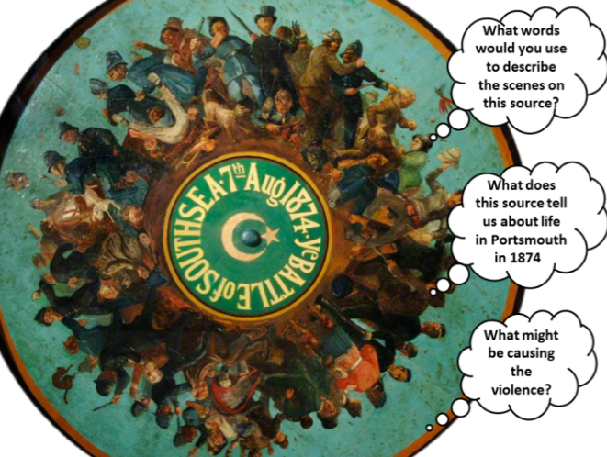
The three lesson enquiry
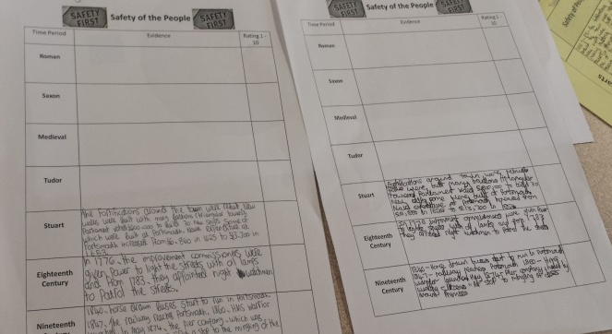
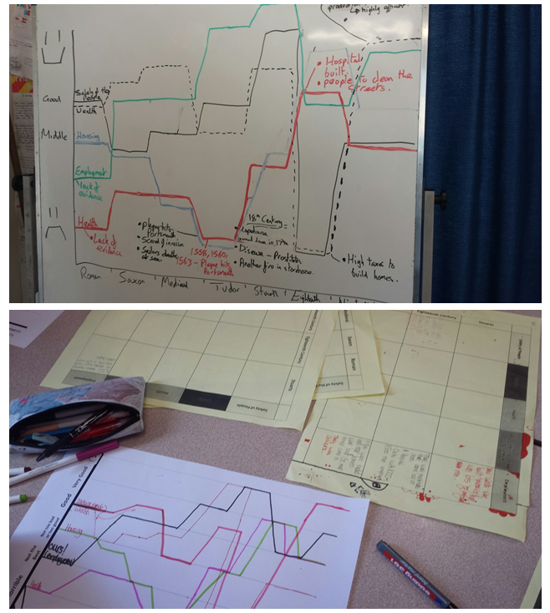
Pupils were seated in groups to begin and they would circulate the different information stations in these groups. The lesson began with pupils analysing a mural of the Battle of Southsea in 1874, in which many working class residents rioted for four days with police, sailors and soldiers to stop a section of Southsea Common being fenced off for the exclusive bathing house. There was opportunity for think, pair, share and a range of questioning to ask pupils what this source tells us about life in nineteenth century Portsmouth. Other hooks before establishing the enquiry included looking at a map of Portsmouth with the twenty-eight fortifcations built to protect it and a painting of Portsmouth Point from the eighteenth century that is on the side of a pub in Old Portsmouth. After establishing the enquiry each group was told what factor they will be researching and what colour square they need to look for to help them research. Pupils were given ten to fifteen minutes at each station, which included Roman, Saxon, Medieveal, Tudor, Stuarts, Eighteenth Century, Nineteenth Century. To add a bit of fun to the investigation the safety of the people group were given protective glasses to wear and the health group were given science lab coats to wear.
Teacher modelling the lines for each factor on the board and an example of pupil’s work. The yellow A3 sheet was the first worksheet I made but was too complicated. An easier edited version was used after, see below.

After the groups had carouselled around the information sheets and were back to their original tables they then debated when it was best to live in Portsmouth according to their factor. They ranked the periods one to seven and then feedback to the class justifying their reasoning. This was an important part of the enquiry as pupils discovered how they were sometimes using the same piece of evidence but making different inferences from it. After the feedback from each group was complete, pupils drew a line on a living graph to visually represent the positive and negative periods to live in Portsmouth. One person from each group then fedback to the teacher their findings, justifying why they had made that judgment from the information they had collected in the carousel activity. The teacher then recorded this line on the board for each group. Every pupil also recorded the other group’s lines so that all had five separate colour lines representing each factor. The lesson finished with a statement that pupils had to support or challenge with the evidence they had collected and learnt from the other groups.

I highly recommend the Challenge Group to any department with young and aspiring colleagues. The process builds confidence, especially in the second meeting where a high level of critiquing and reflection is encouraged to elevate your lesson to the best it possibly can be. It was from the Challenge Group that I was given the chance to attend the Hampshire History Leadership Conference where my lesson was shared with many colleagues across the county.

