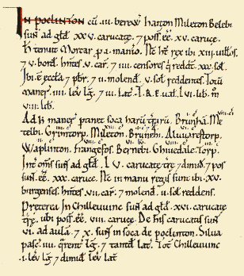
Pocklington
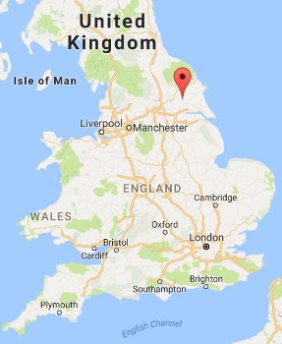
It was a very small place in the east of Yorkshire, but it paid quite a lot of tax. It had 96.5 hides, that is, areas of land that were taxed. In 1066 the manor of Pocklington was owned by Morcar, the Earl of Northumbria. In 1086 the manor was owned by King William. There was land for 53 ploughs. There were 13 villagers, 5 small farmers, a priest and 15 townspeople. There was a church, 3 mills and some woodland. In 1066 the manor was worth £56 and in 1086 it was worth £8.
Ravensthorpe
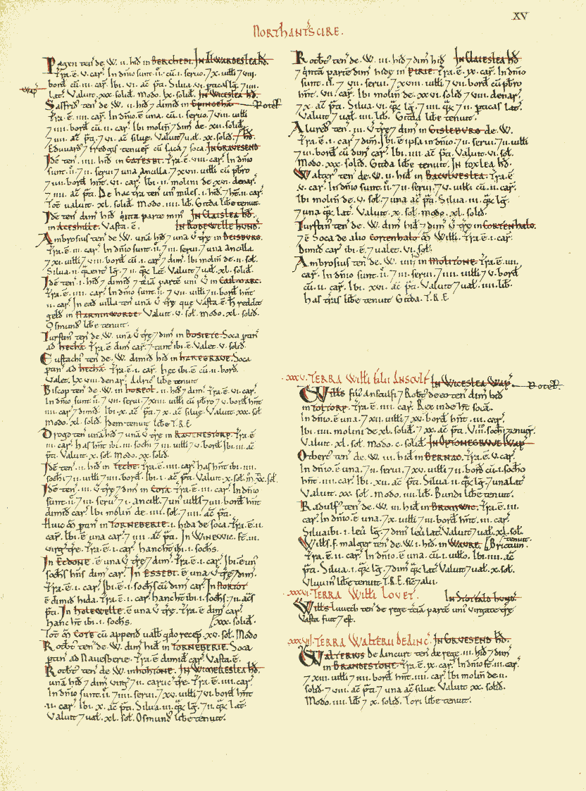
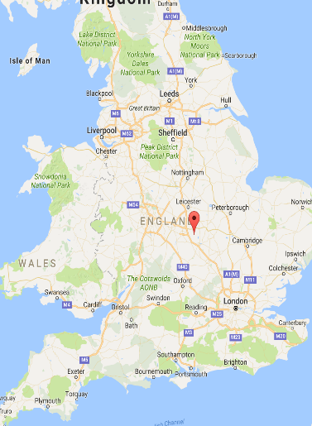
It was a medium sized place in Northamptonshire, but it paid quite a small amount of tax. It had three entries in the Domesday Book. In 1066 the landowners in Ravensthorpe were Drogo of Stoke, Edmer and Northmann. In 1086 the land was owned by William Peverel, Robert Count of Mortain and Gilbert the Cook. The land was taxed at 2.1 geld units. There was land for 5.5 ploughs. There were 5 villagers, 7 small farmers and 3 freemen. There were 3 acres of meadows. In 1066 the manor was worth £1 and by 1086 it was worth £1.6.
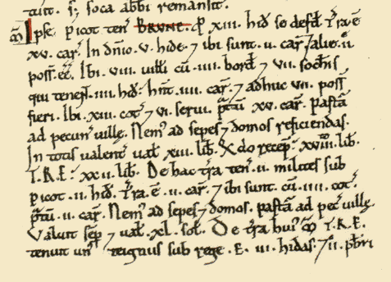
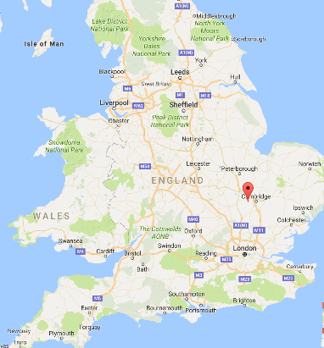
Bourn
It was a very large place in Cambridgeshire paying a very large amount of tax for the time. The land was assessed as having 20 geld units for tax. It had four entries in the Domesday Book. In 1066 there were 24 different landowners in Bourn, including a man called Almer and the Abbey of Ramsey. By 1086 most of the land was controlled or tenanted by Picot of Cambridge. Almer still had some of his land, but he was a tenant of Picot and a man called Count Alan of Brittany. The Abbey of Ramsey still owned its land. There were 17 villagers, 21 small farmers, 8 slaves, 7 freemen and 20 cottagers (who owed service to the Lord). There was land for 25.5 ploughs. There were meadows. In 1066 the manor was worth £32 and by 1086 it was worth £26.

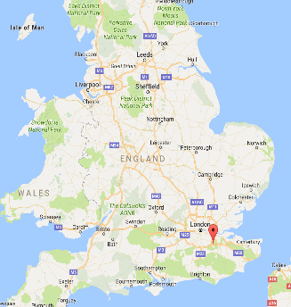
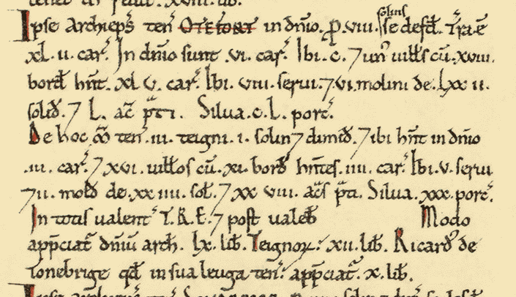
Otford
It was a very large place in Kent paying a very large amount of tax for the time. The land was assessed as having 8 geld units for tax. In 1066 the land was owned by the Archbishop of Canterbury. It was still owned by the Archbishop in 1086. There were 117 villagers, 29 small farmers and 13 slaves. There was land for 42 ploughs. There were lots of meadows and woodland for pigs. There were also 8 mills. The value of the land in 1066 is not recorded. We can assume it was not more than the value in 1086 which was £82.

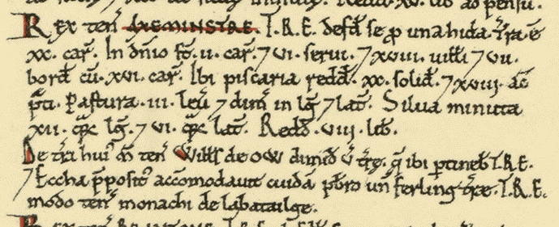
Exminster
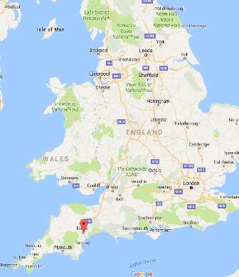
It was a very large place in Devon that paid quite a small amount of tax. It was assessed as having 2 geld units for tax. It appears twice in the Domesday Book. The overlords in 1066 were Eccha the Reeve and a Viking man. By 1086 the land was held King William and a man called William Goat. There were 24 villagers, 9 small farmers and 10 slaves. There was land for 25.5 ploughs. There were meadows, pastures for animal grazing, woodland and a fishery. In 1086 there were 4 cattle, 1 horse and 220 sheep. The value of the land in 1066 was £9 and in 1086 it was £9.9.

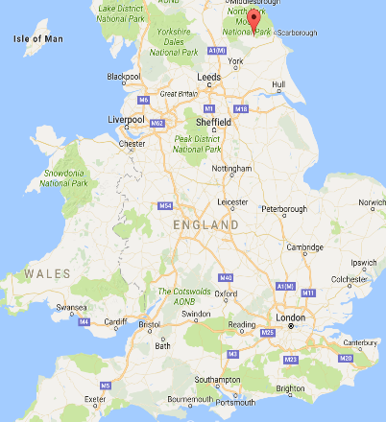
Pickering
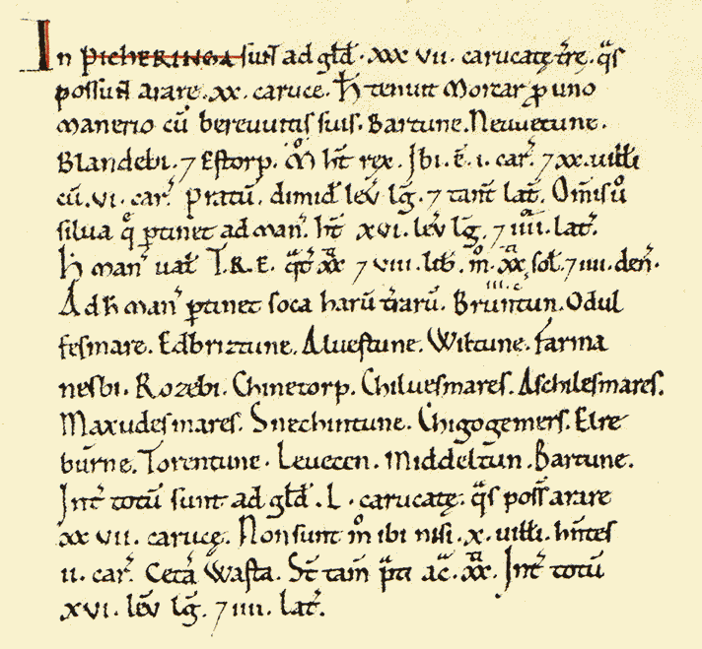
It was a very small place in Yorkshire that paid a medium amount of tax. In 1066 it was owned by Earl Morcar. In 1088 it was owned by King William. It had 87 hides of land that could be assessed for tax. There were 30 villagers. There was land for 47 ploughs, though most of it was not being ploughed in 1088. There were meadows and woodland. The value of the land in 1066 was £88 and in 1086 it was £1.

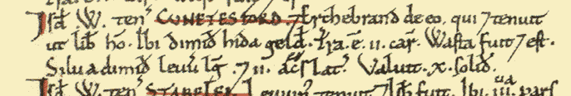
Knutsford
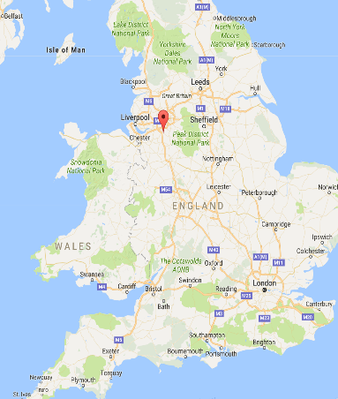
It was a very reasonable place in Cheshire that paid a very small amount of tax. In 1066 it was owned by a man called Erchenbrand. He still owned it in 1086, but by then he had a Norman overlord called William FitzNigel. The land was taxed at 0.5 geld units. There are no recorded villagers in the Domesday Book. There was land available for two ploughs. There were meadows and woodland. The value of the land in 1066 was £0.5. By 1086 the land was worth nothing, it was wasteland.

Wakefield
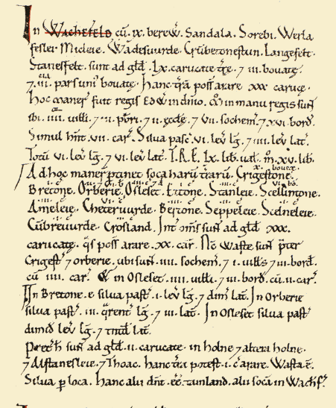
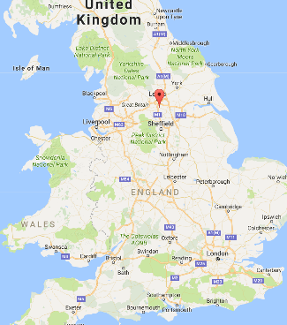
It was a very small place in Yorkshire that paid a medium amount of tax. At the start of 1066 it was owned by King Edward the Confessor. By 1086 it was owned by King William the Conqueror. The 92.4 hides of land were assessed for tax as 3.4 geld units. There were 9 villagers, 22 small farmers, 11 freemen and 3 priests. Land was available for 51 ploughs, but there were only 13 plough teams in 1086. There were also woods, meadows and two churches. The value of the land in 1066 was £60. However, by 1086 the value had fallen to £15.

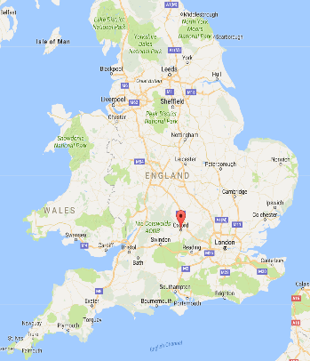
Oxford
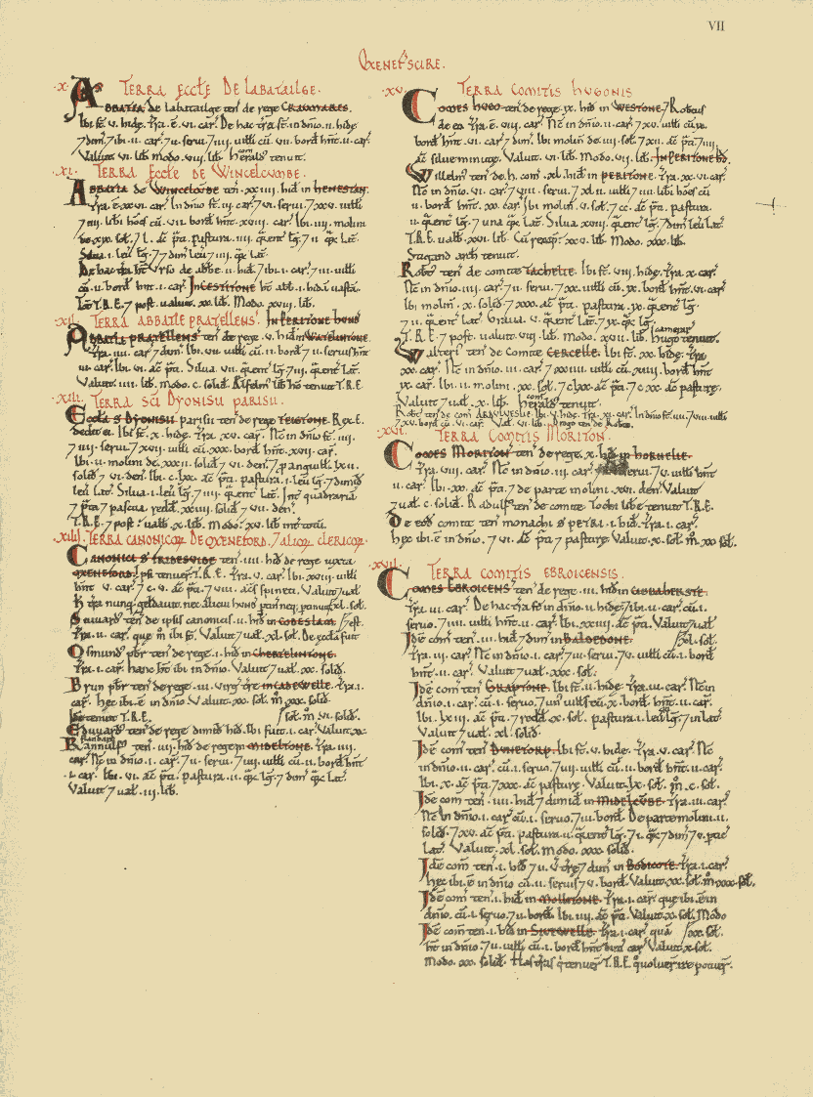
It was a medium sized place in Oxfordshire that paid tax at a medium rate. In 1066 it was owned by the church, specifically the canons of St Frideswide. They still owned it in 1086. The land was exempt from tax. There were 18 villagers. Land was available for 5 ploughs and all of it was under the plough in 1086. There were also 105 acres of meadow and 8 acres of woodland. The value of the land was £2 in 1066 and in 1086.

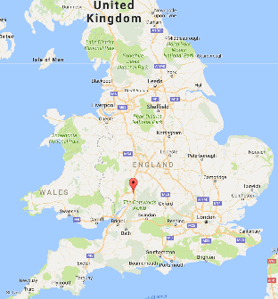
Tewkesbury
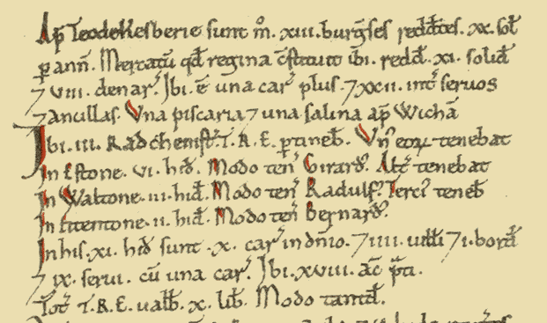
It was quite a small town in Gloucestershire that paid quite a large amount of tax. It was taxed on 45 geld units. In 1066 it was owned by Brictric son of Algar, but the overlord by 1086 was King William and the land was rented to Normans. There were 4 villagers, 2 small farmers, 31 slaves, 5 freemen and 13 townsmen. There was land for 26 ploughs and most of it was being used. There were 138 acres of meadows, woodlands, 2 mills, 2 fisheries and 2 salthouses. The value of the land was £10 in 1066 and in 1086.

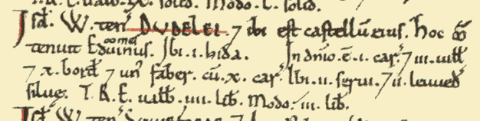
Dudley
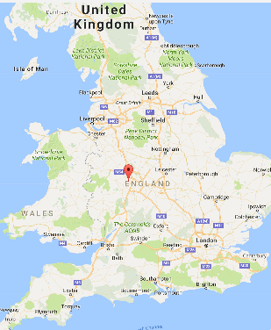
It was a medium sized place in Worcestershire and the tax it paid was very small. It only paid tax on one geld unit. In 1066 it was owned by Earl Edwin. In 1086 it was owned by the Norman man William, son of Ansculf. There were 3 villagers, 10 small farmers, 2 slaves and 1 smith. There were 11 plough teams. There were 2 leagues of woodlands. The value of the land was £4 in 1066 and £3 in 1086.

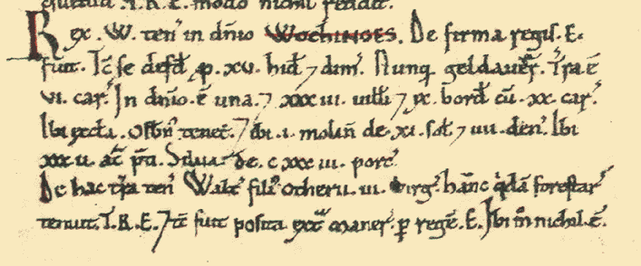
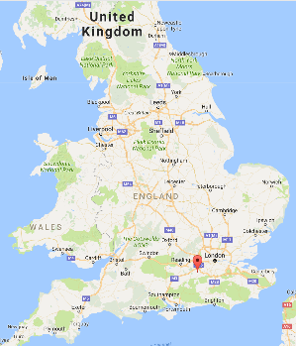
Woking
It was a very large place in Surrey paying a lot of tax, but also with exemptions from tax. It was owned by King Edward in 1066 and the overlord was King William in 1086. The other land owner was Exeter Cathedral and it owned the land in both 1066 and 1086. There were 53 villagers 15 small farmers and 3 slaves. There were 15.5 ploughlands. There were 46 acres of meadows, woodland for pigs, 2 mills and a church. In 1066 the land was valued at £25 and in 1086 at £24.5.

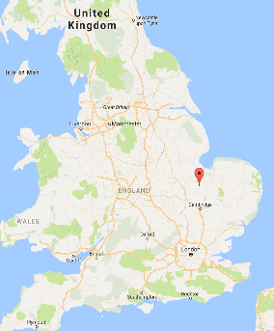
March
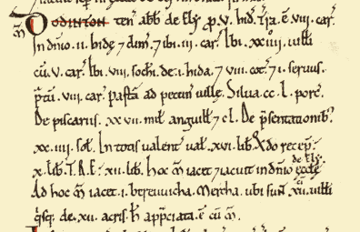
March was quite a large place in Cambridgeshire that paid a medium amount of tax. There were just over 5 geld units for tax. Tax was also paid on the fisheries. In 1066 the land was owned by St Etheldreda’s Abbey in Ely and the Abbey of Bury St Edmunds. They still held the land in 1086. There were 36 villagers, 3 small farmers, 1 slave, 8 freemen and 8 cottagers (who owed service to the lord of the manor). There was land for 8.5 ploughs. There were also meadows, woodland for pigs and 2 fisheries. The land was valued at £12.20 in 1066 and £16.20 in 1088.

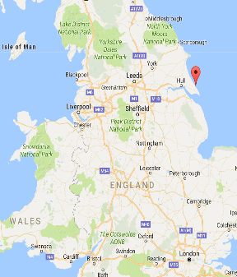
Withernsea
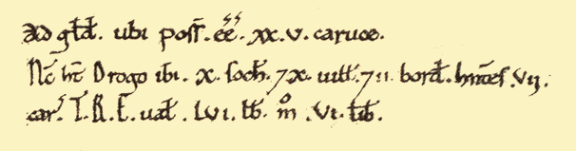
This was a very small place in Yorkshire that paid quite a large amount of tax. It was owned by Earl Morcar in 1066 and by Drogo of la BeuvriËre, a Norman, in 1086. There were 50.8 geld units assessed for tax. There were 14 villagers, 7 small farmers, 10 freemen and 2 priests. There was land for 40 ploughs, but only a quarter of the land was being ploughed in 1086. There were also 100 acres of meadow. The land was worth £56 in 1066 and just £6 in 1086.

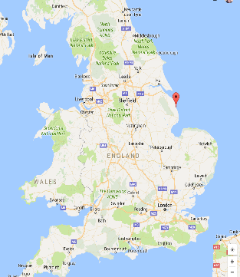
Mablethorpe
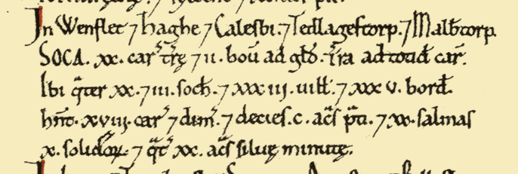
This was a very large place in Lincolnshire that paid quite a lot of tax. In 1066 the land was owned mostly by Earl Harold Godwinson, with some land owned by Julfr and Tonni of Lusby. In 1086 most of it was owned by Earl Hugh of Chester, with some owned by Rainer of Brimeux and Gilbert of Ghent. It paid tax of 21.3 geld units and also tax on salt. There were 42 villagers, 35 small farmers and 83 freemen. There was land for 22.6 ploughs, 1040 acres of meadow, 80 acres of woodland and 20 salthouses. No land value is given, which is unusual.

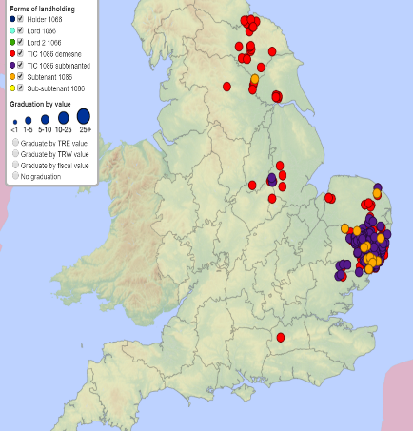
Robert Malet
Robert Malet was the son of William Malet who had arrived in England and fought with William the Conqueror at Hastings. William Malet died in 1071 and Robert inherited his lands. His lands in England were concentrated in Suffolk, but he also had land elsewhere in East Anglia, the Midlands and in Yorkshire. The Domesday Book reveals that his land had been owned by over 30 named English people in 1066, and other unnamed free farmers also lost this land to him. The value of his land was £504.03 in 1066 and £584.63 in 1086. His land in Yorkshire had lost value by 1086 and some of it was valued at £0.

Abbot Leofric
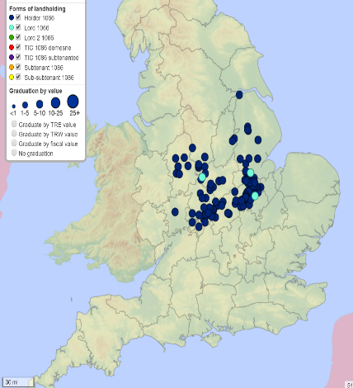
In 1066 Leofric was abbot of the abbeys of Peterborough, Burton, Thorney, and Coventry. As a result, he was lord of lands across the Midlands of England worth £322.78. The Domesday Book shows that he held no land in 1086. The land he had held was now held by ten people. There were four abbots for the four different abbeys. Some of his land had also gone to Normans who were not part of the church, including King William and Countess Judith, his niece. The total value of this land was £465.76.

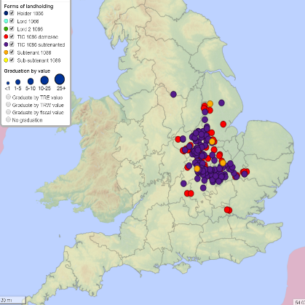
Countess Judith
Judith is one of the few women named in the Domesday Book. She was the niece of William the Conqueror and in 1070 she married the Anglo-Saxon Earl Waltheof. He had an earldom in the Midlands before 1066 and had attacked the castle in York in 1070. He submitted to William once more and became Earl of Northumberland. The couple had three children, but Waltheof rebelled again in 1075 and was executed. By 1086 Judith held land in England across the Midlands worth £769.79. It had been worth £579.32 in 1066. Most of this land had been Waltheof’s, but she also had land from over 20 other named men and also other unnamed Anglo-Saxon freemen.

