Research chart for places
Complete this chart using your extract ready to help answer the enquiry question: What can Domesday Book reveal about the impact of the Norman Conquest? The questions (except for the last one) are based on the actual questions asked by the Domesday commissioners in 1086.

What was the place called?
Who owned it in 1066?
Who owned it in 1086?
What can you find out about how much tax it could pay?
How many ploughs were possible?
How many people were there?* (How many different types of people were there?)
What was the land used for?
What other things were in the place?
How much was the land worth in 1066?
How much was the land worth in 1086?
What do you think is the surprising, or unusual, or remarkable thing about this place?
* Historians of Domesday tell us that these numbers are for householders and they therefore estimate the total population would be about 5 times greater than the numbers in Domesday.

Research chart for people
Complete this chart using your extract ready to help answer the enquiry question: What can Domesday Book reveal about the impact of the Norman Conquest?

What was the person called?
Were they a landowner in England 1066?
Where did they own land in England in 1086?

How many people’s lands did they take over? OR How many people owned their land in 1086?

How much was the land they held worth in 1066?
How much was the land they held worth in 1086?
What do you think is the surprising, or unusual, or remarkable thing about this person?

Domesday England
Either: write the name of the place you have researched neatly on the right place on the map.
Or: write the name of the person you have researched in the parts of the country where they held a lot of land.
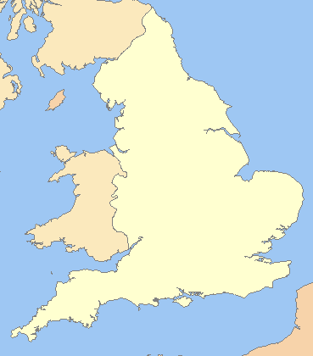

Had land changed hands?
Did the person you researched gain lands after 1066?
Did different people own the land in 1066 than in 1086?
WRITE THE NAME OF YOUR PLACE OR PERSON IN THE CORRECT COLUMN.
YES – the land changed hands / the person gained/lost land after 1066 | NO – there was the same landowner in 1066 as in 1086. (If you write in this column, also write the name of the place AND the landowner who kept their land).

How many people owned the land?
How many people owned land in your place in 1066? How many people owned land in your place in 1086? If you research a person, how many people’s land from 1066 did that person have by 1086?
WRITE THE NUMBER OF PEOPLE WHO OWNED THE LAND IN 1066 IN THE FIRST COLUMN AND THE NUMBER OF PEOPLE WHO OWNED THE LAND IN 1086 IN THE SECOND COLUMN. IF YOU RESEARCHED A PERSON THEN YOU WILL BE PUTTING A NUMBER 1 IN THE 1066 or 1086 COLUMN.
Number of land owners in 1066 | Number of land owners in 1086

Had the land value….?
You now need to decide if the land you have researched went up or down in value between 1066 and 1086. Decide whether the land value relating to your place or person went up: a lot, a bit, stayed the same, went down a bit, went down a lot.
WRITE THE NAME OF THE PLACE OR PERSON IN THE CORRECT COLUMN.
Value went  up a lot | Value went  up a bit | Value stayed  the same | Value went  down a bit | Value went  down a lot

Has the Domesday survey revealed information useful for knowing who owned the land, what land was like and how much tax could be paid?
Decide the answer to this question for your place or person and write the name of the place / person in the correct column.
Yes – useful information collected | No – the information collected would not have been useful

