Jewish Lawyers and Notaries are in future not allowed to conduct legal affairs in the city of Berlin

18th March 1933

After the 1st April 1933 costs arising for treatment by Jewish doctors are no longer refunded by the City of Berlin Health Insurance Company

31st March 1933

Jewish Judges are suspended from Office

31st March 1933

All district councils are to relieve Jewish teachers in municipal schools of their office with immediate effect

1st April 1933

Jewish civil servants are dismissed from public office

7th April 1933

Aryan and non – Aryan children are forbidden to play with each other

April 1933

Jews are excluded from sport and gymnastics clubs

25th April 1933

Films are only recognised as German films if made by German citizens of German descent

28th June 1933

 |  | Jews are excluded from the German Chess Federation  9th July 1933

Jews are excluded from choirs

16th August 1933

Jews are not allowed to use the Wannsee bathing beach

22nd August 1933

 |  | Genetics and Ethnology are introduced in all schools as part of the examination syllabus  13th September 1933

Jews are not admitted to the newly created Automobile Club as a result of compulsory merger

1st October 1933

Jewish musicians are not allowed to practise their profession

31st March 1935

Jewish writers are not allowed to write or engage in any other form of literary activity in Germany

March 1935

In the ‘Bayerischen Platz’ Jews are only allowed to use the benches with yellow markings

April 1935

Young Jews are not allowed to go on hikes in groups of more than 20

10th July 1935

Nuremberg Laws
Marriage ceremonies and extra marital intercourse between nationals of German stock and Jews are punishable by imprisonment.

Marriages which persons have entered into despite this are invalid

15th September 1935

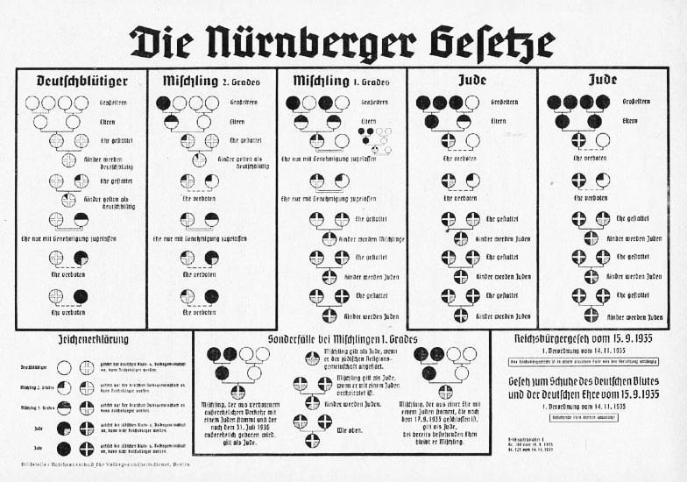 |  | Nuremberg Laws  Jews are recognised only as state subjects whilst Aryans are citizens of the Reich  15th September 1935

Jewish art and antique dealers are prohibited from practising their trade

They must close down their business within 4 weeks

1935

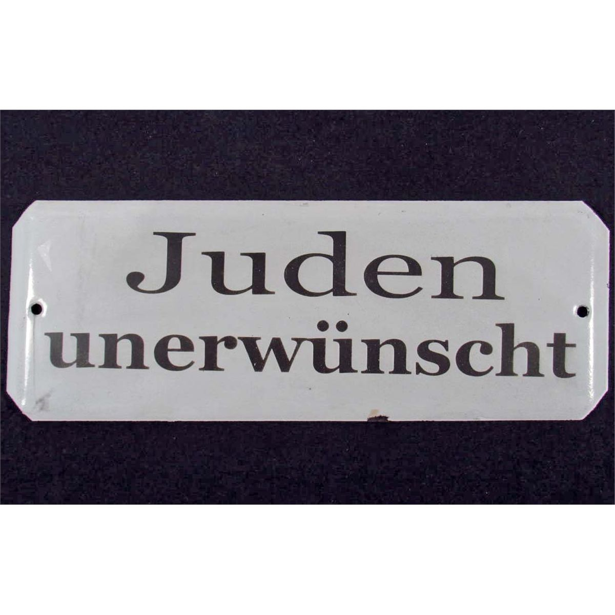 |  | In order not to give visitors from abroad a bad impression the signs whose contents are extreme are to be removed.  It is sufficient to have signs such as ‘Jews are not welcome here’  29th January 1936

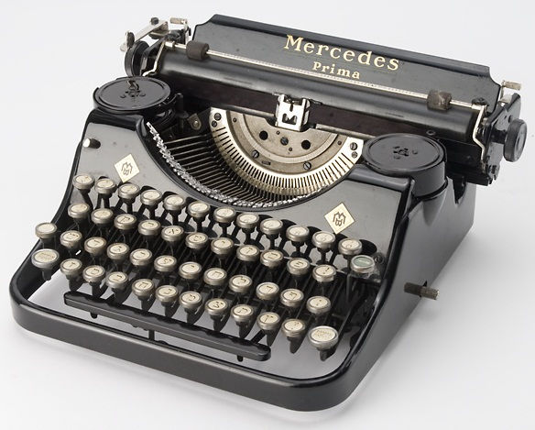 |  | Jews must hand over their electrical and optical equipment, bicycles, typewriters and records  29th January 1936

Jewish Veterinary Surgeons are not allowed to establish a practice.

General ban on practising the profession

3rd April 1936

Journalists must establish their Aryan descent back to 1800 for both themselves and their spouses

14th April 1936

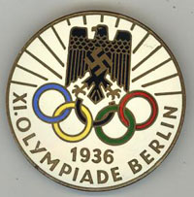 |  | The anti – Jewish posters put up in Berlin are temporarily removed during the Olympic Games in 1936  August 1936

Baptism of Jews and conversion to Christianity have no significance for the question of race

4th October 1936

 |  | Jews are forbidden to obtain a doctorate  15th April 1937

Post Office officials married to a Jewess are given early retirement

8th June 1937

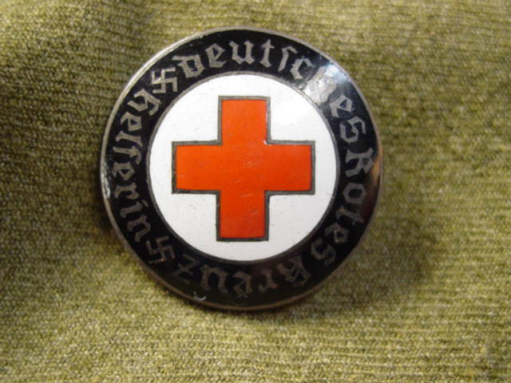 |  | Jews cannot be members of the German Red Cross  1st January 1938

Only honourable national comrades of Germany or ethnically related stock can become allotment holders

22nd March 1938

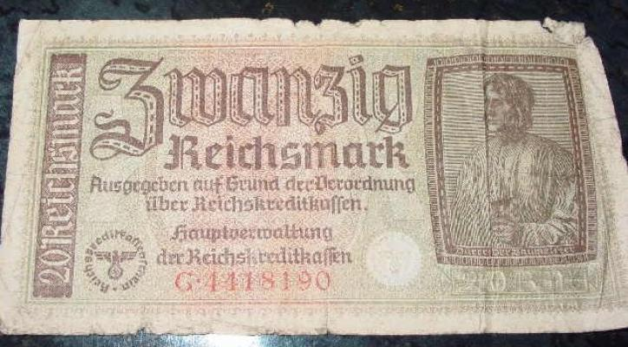 |  | Jews are required to disclose their financial circumstances in order to ensure that their assets are being used in the interest of the German economy  26th April 1938

Jewish doctors are not allowed to practise any more

25th July 1938

 |  | Jewish street names are changed. Haberland Street named after the founder of the Bavarian district was renamed Treuchtlinger and Nordlinger Street  27th July 1938

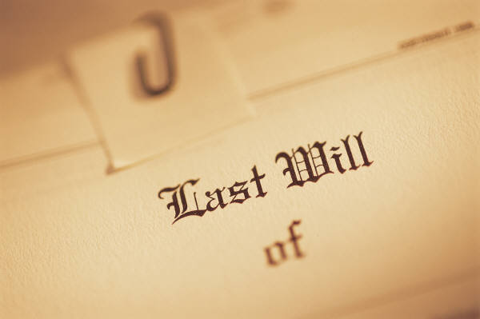 |  | Testamentary bequests to Jews are annulled if it offends against normal popular sentiment  31st July 1938

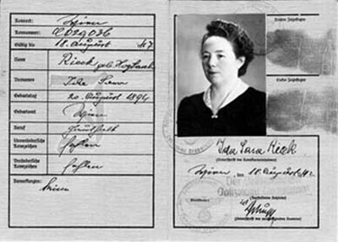 |  | Male Jews must add the name ‘Israel’ and female Jews the name ‘Sara’ to their first names  17th August 1938

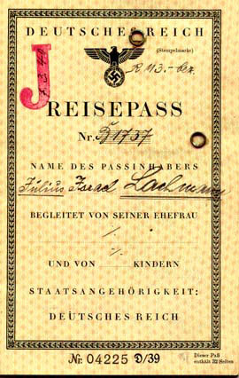 |  | Jewish passports have to be stamped with a  ‘J’  Passports of Jews whose emigration is undesirable are to be confiscated  5th October 1938

In an organised ‘pogrom’ in 1938 many Jews are murdered and Jewish shops and synagogues destroyed

Thousands are deported to concentration camps

November 1938

Jewish actresses and actors are forbidden to carry out their profession

12th November 1938

Jews are no longer allowed to conduct independent business as craftsmen

12th November 1938

 |  | Jews are banned from conducting a retail or wholesale business  12th November 1938

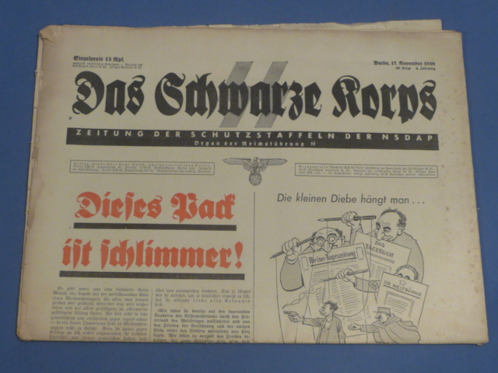 |  | Jews are no longer allowed to buy newspapers and magazines  12th November 1938

Jews are banned from visiting cinemas, theatres, operas and concerts

12th November 1938

All Jewish children are expelled from non Jewish state schools

15th November 1938

Jewish driving licences and vehicle permits are declared invalid and must be handed over

3rd December 1938

Jews are not allowed to use open – air and indoor swimming pools

3rd December 1938

Jewish publishing houses and bookshops are to be closed down by the end of the year

December 1938

Jews are banned from certain districts in the city of Berlin

3 December 1938

Jewish women are refused recognition as midwives

21st December 1938

 |  | Emigrants are not allowed to take jewellery and valuables with them  16th January 1939

Jewish dentists, dental technicians, chemists, non-medical practitioners and nurses are forbidden to practise

17th January 1939

Jews have to hand over jewellery, gold, silver, platinum and pearls

21st February 1939

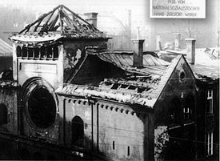 |  | Jewish cultural organisations are responsible for removing the ruins of synagogues. Reconstruction is not permitted  24th March 1939

 |  | Jews can be evicted from their homes without a reason given and without the terms of notice being served  30th April 1939

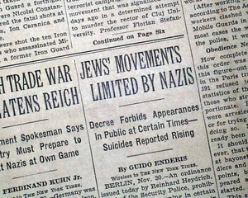 |  | Jews are no longer allowed to leave their homes after 8.00pm (or 9.00pm in the summer)  1st September 1939

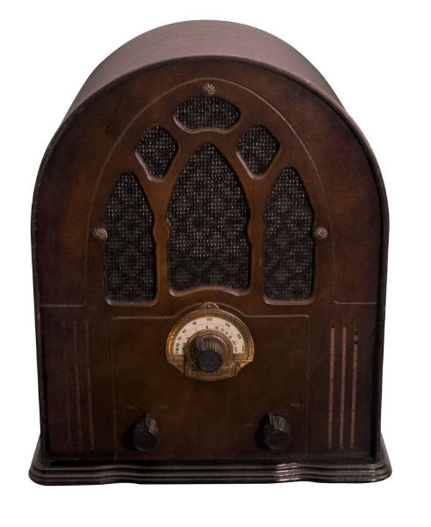 |  | Jews have to hand over their radio sets  23rd September 1939

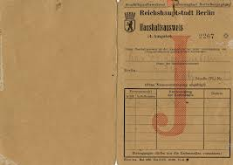 |  | Jews no longer receive ration cards for clothes  January 1940

Jews are only allowed to make purchases of groceries in Berlin between 4pm and 5pm

4th July 1940

All Jews are compelled to
forced labour

4th March 1941

Jewish children are only allowed to use public transport if their school is further than 5 km from their home

24th March 1941

Jews are no longer to receive soap and shaving soap

26th June 1941

Jews have their telephones disconnected by the post office

The use of public telephones is prohibited

29th July 1941

 |  | Jews are not allowed to use public libraries  2nd August 1941

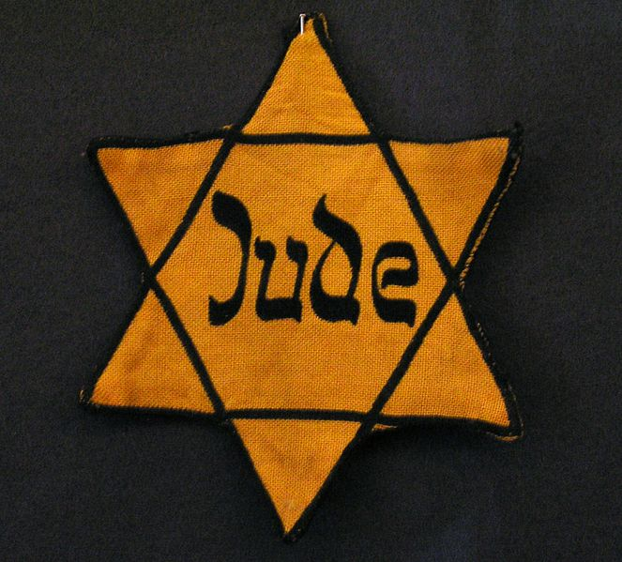 |  | All Jews over the age of 6 have to wear the yellow star with the word Jew written on it  1st September 1941

Jews are only allowed to use public transport on their way to work

13th September 1941

 |  | During rush hour Jews are not permitted to use public transport  They are only allowed to occupy a seat if no other passengers are standing  18th September 1941

Jews need a police permit if they want to leave their place of residence

18th September 1941

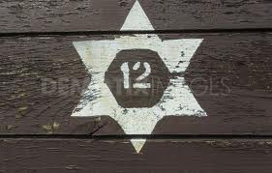 |  | The first mass deportation of Berlin Jews  18th October 1941

“The moment has come, tomorrow I have to go and of course that hits me very hard....I shall write to you before the deportation.

The powder compact is intended for you personally as a little souvenir of me; use it often, then you’ll think of me.

In deep sadness, yours Else Stern

16th January 1942

Jews are forced to hand over furs and woollen clothing

January 1942

 |  | In bakery shops and cake shops signs are to be posted that cake is not sold to Jews and Poles  14th February 1942

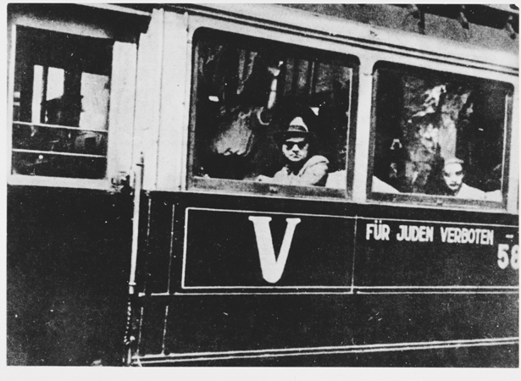 |  | Jews are only allowed to use public transport if their workplace is more than 7 km from their home  24th March 1942

It is made compulsory for Jewish residences to be marked with the Star of David

26th March 1942

 |  | All use of public transport is prohibited  24th April 1942

Jews are no longer allowed to keep pets

15th May 1942

Jews no longer receive cigarettes or cigars

11th June 1942

 |  | All schools closed to Jewish children  20th June 1942

Jews no longer receive eggs

22nd June 1942

 |  | Jews are forbidden to use ticket machines  26th June 1942

 |  | No fresh milk for Jews  10th July 1942

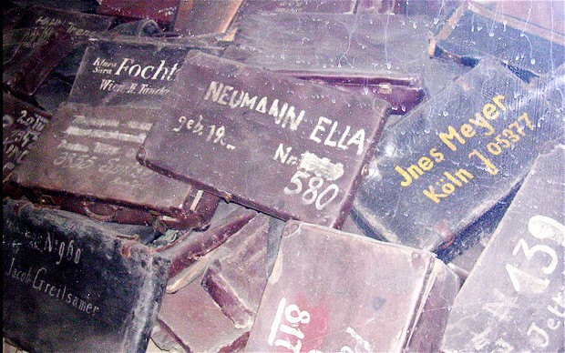 |  | The first deportation of Berlin Jews directly to the extermination camp at Auschwitz  11th July 1942

Poles and Jews cannot give evidence in court against Germans

7th August 1942

The supply of meat produces and other rationed goods to Jews is discontinued

18th September 1942

Jews are no longer allowed to buy books

9th October 1942

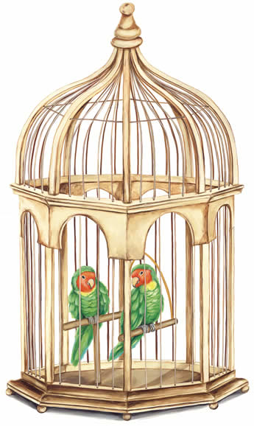 |  | “We had a budgie. When we heard of the regulation that Jews were not allowed to keep pets my husband couldn’t bear to be parted from the bird.....perhaps someone denounced him, for one day my husband got a summons to go to the Gestapo....After many weeks of anxious waiting I received a card from the Police telling me to collect my husband’s urn on payment of a fee of 3 Reichsmark  (Report from the year 1943)

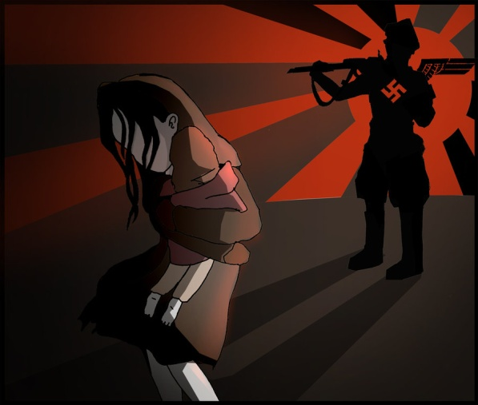 |  | Organised arrests at the workplace for deportation  26th March 1943

Files which deal with anti-Jewish activities are to be destroyed

16th February 1945

