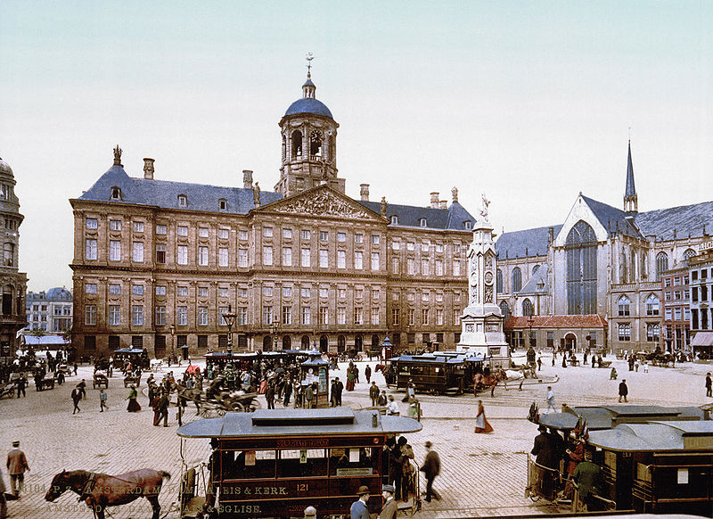 | 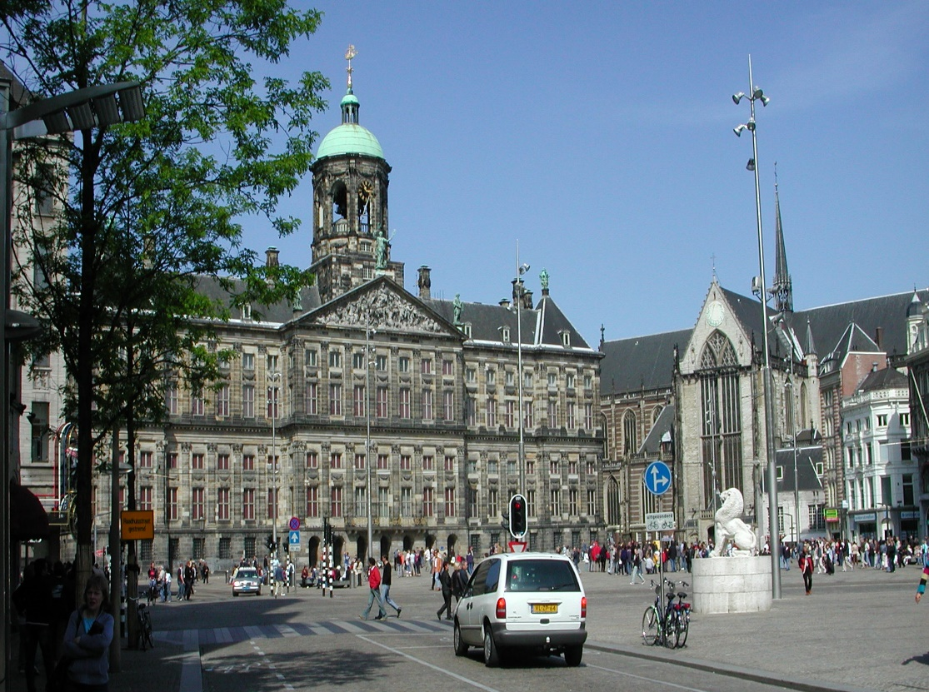
Picture A: Dam Square, Amsterdam, about 1900 | Picture B: Dam Square, Amsterdam, about 2000

