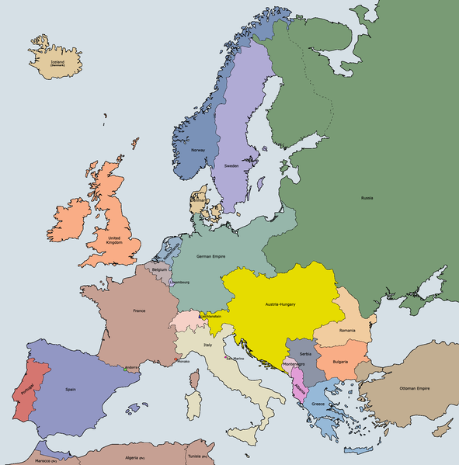

A: A map of Europe from about 1900
https://commons.wikimedia.org/wiki/File:Europe_1914_(coloured).png

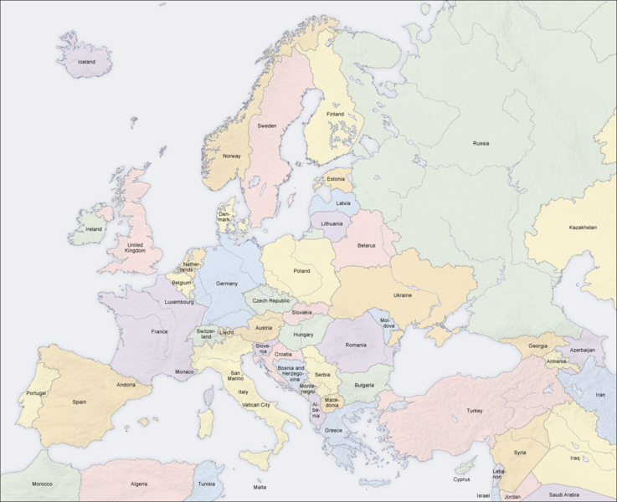

B: A map of Europe from about 2000

https://commons.wikimedia.org/wiki/File:Europe_countries_map_en.png
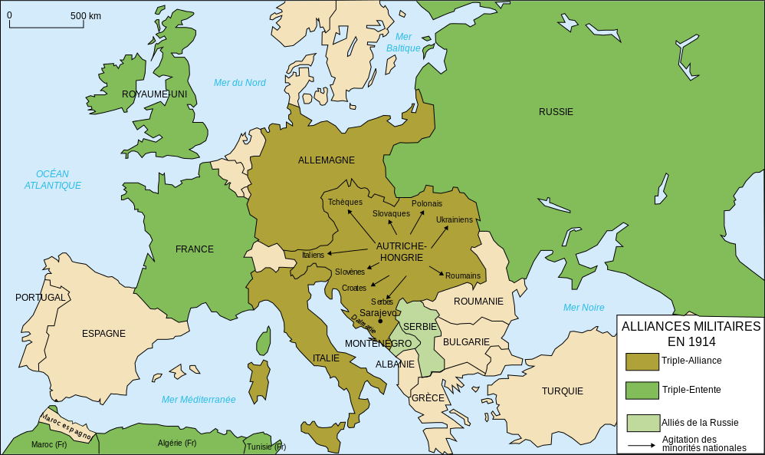
C: A map showing the alliances of 1914
https://wo.wikipedia.org/wiki/Xareb_%C3%80dduna_bu_Nj%C3%ABkk#/media/File:Map_Europe_alliances_1914-fr.svg

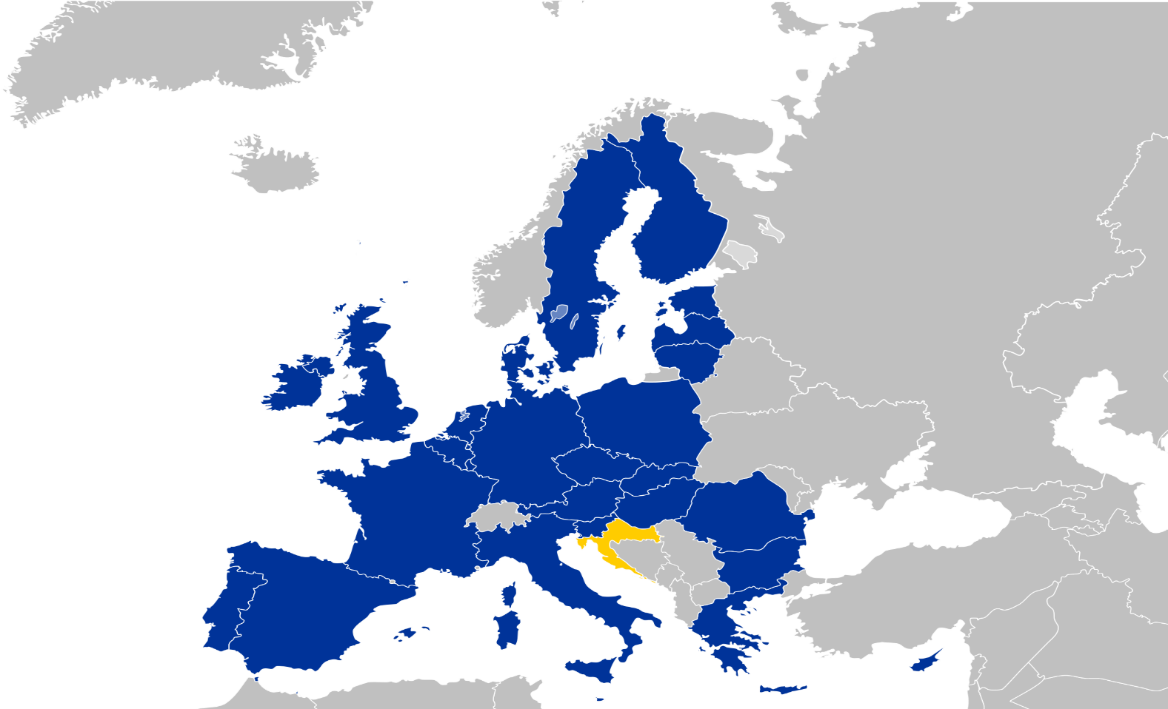

D: A map showing the EU member states in 2010

https://en.wikipedia.org/wiki/History_of_the_European_Union#/media/File:EC-EU-enlargement_animation.gif
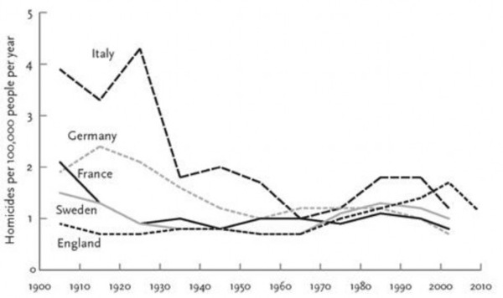

E: The number of homicides (murder) per 100,000 people per year
Max Roser (2015) – ‘Homicides’. Published online at OurWorldInData.org. Retrieved from: http://ourworldindata.org/data/violence-rights/homicides/ [Online Resource]

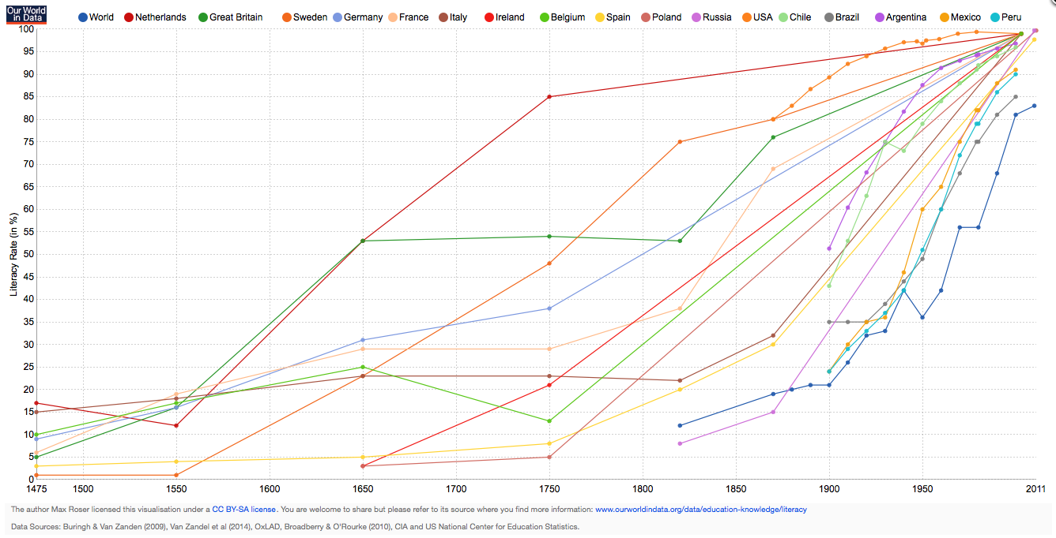

F: World literacy rates

G: Dates European countries achieved univeral suffrage

Austria 1918, Belgium 1948, Denmark 1915, France 1944, Finland 1906
Germany 1919, Hungary 1918, Italy 1945, Netherlands 1919, Norway 1913
Poland 1918, Portugal 1931, Sweden 1919, United Kingdom 1928

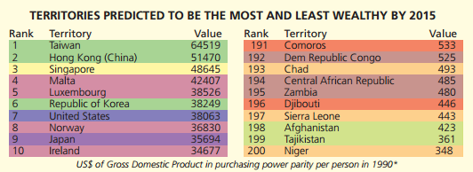

H: The most and least wealthy countries in 2015
Creative Commons Licence. © Copyright Sasi Group (University of Sheffield) and Mark Newman (University of Michigan)
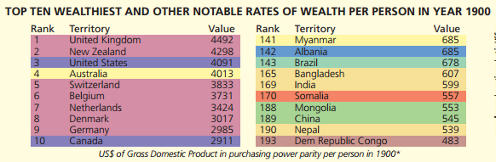

I: The most and least wealthy countries in 1900
Creative Commons Licence. © Copyright Sasi Group (University of Sheffield) and Mark Newman (University of Michigan).
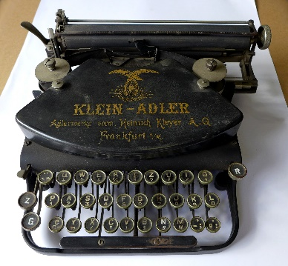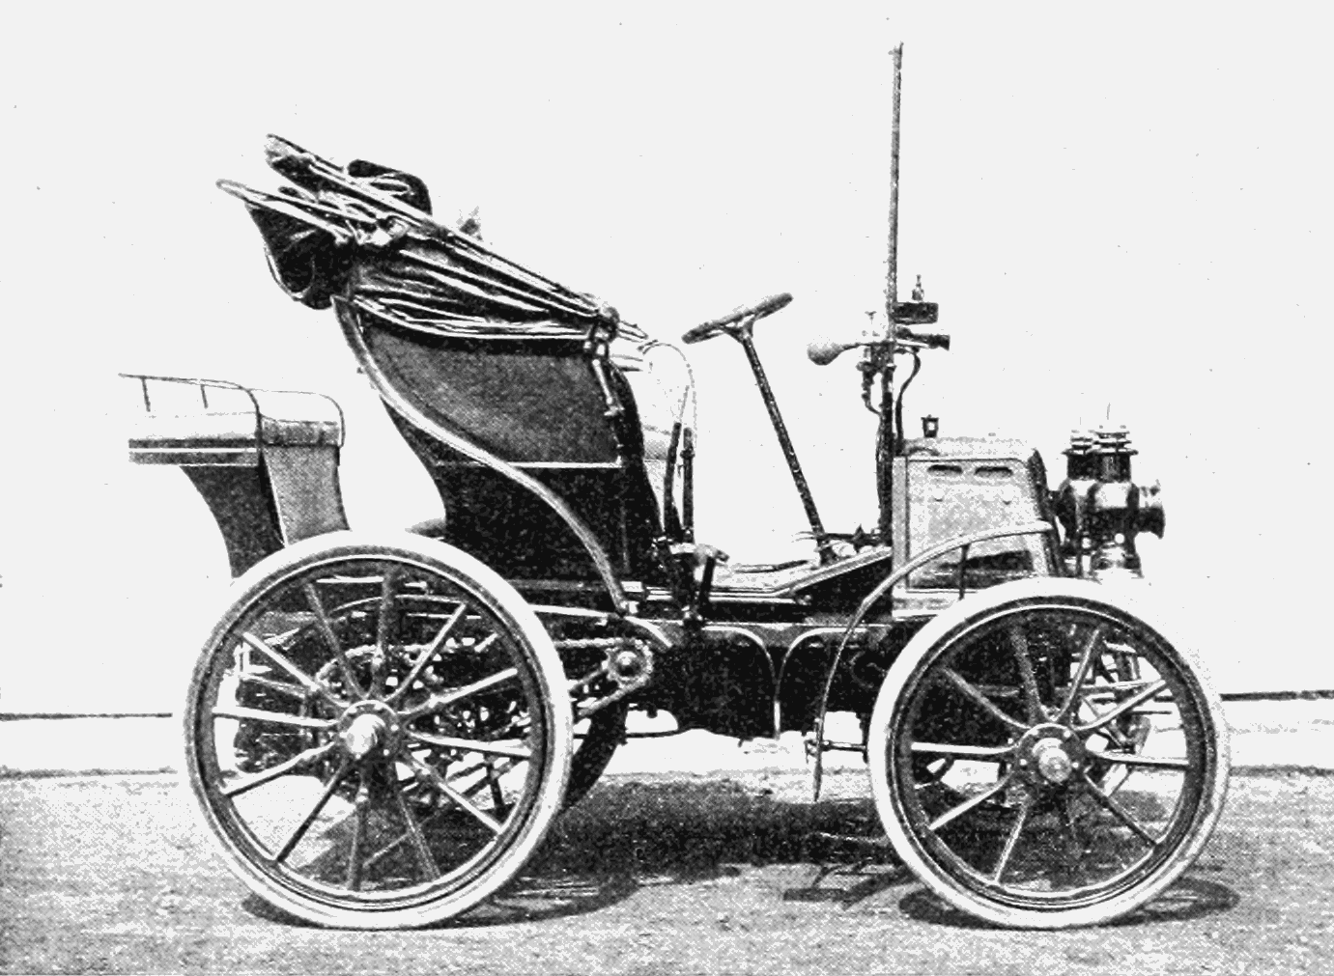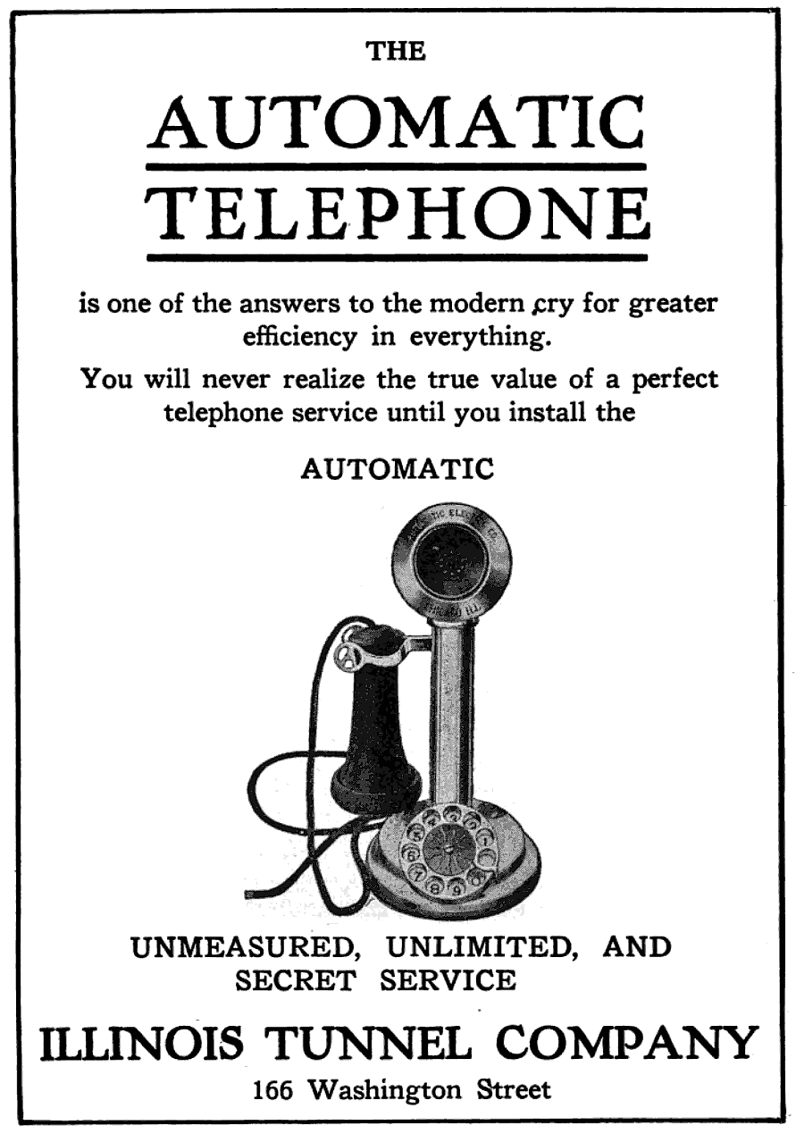
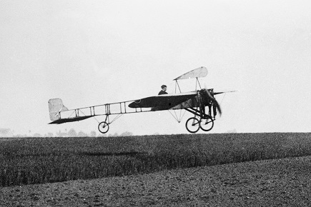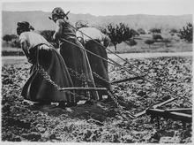

J: Technology in 1900

https://upload.wikimedia.org/wikipedia/commons/f/f0/Klein-Adler_um_1900.jpg https://upload.wikimedia.org/wikipedia/commons/5/58/PSM_V57_D609_Panhard_and_levassor_vehicle.png https://upload.wikimedia.org/wikipedia/commons/0/0e/IllinoisTunnelAdNews.png https://upload.wikimedia.org/wikipedia/commons/0/03/Bleriot.jpg https://upload.wikimedia.org/wikipedia/commons/thumb/6/6c/Heroic_Women_of_France._Hitched_to_the_plough,_cultivating_the_soil._All_agriculture_rests_upon_their_shoulders._Uncompl_-_NARA_-_512429.tif/lossy-page1-220px-Heroic_Women_of_France._Hitched_to_the_plough,_cultivating_the_soil._All_agriculture_rests_upon_their_shoulders._Uncompl_-_NARA_-_512429.tif.jpg
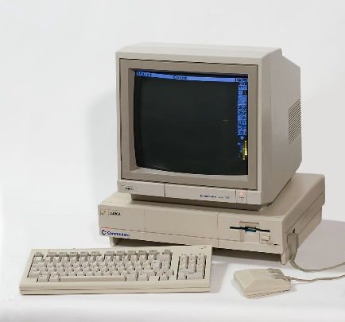
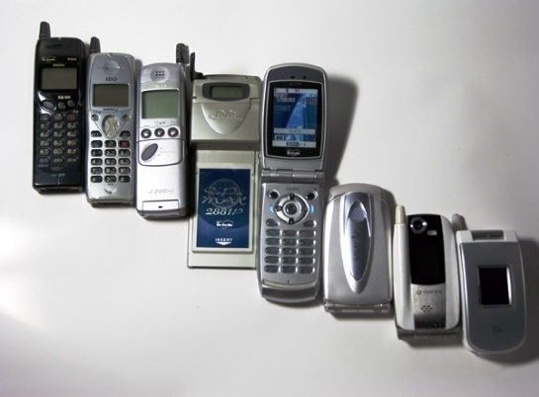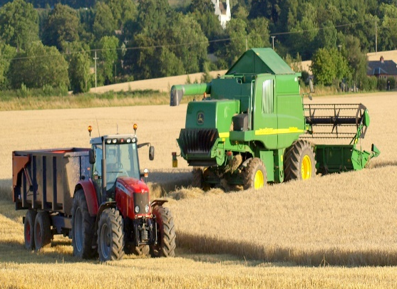
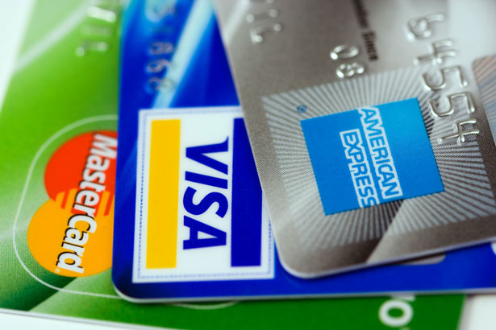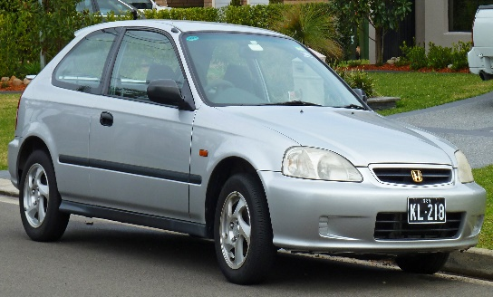

K: Technology in 2000

https://upload.wikimedia.org/wikipedia/commons/6/65/Mobile_phone_evolution_Japan1997-2004.jpg https://www.google.nl/search?q=alliances+of+1914+commons+licence&rlz=1C1CHWA_enGB603GB603&espv=2&biw=1440&bih=859&source=lnms&tbm=isch&sa=X&ved=0CAYQ_AUoAWoVChMIlIfg04fGxwIV4SPbCh3inQs2#tbm=isch&q=technology+in++2000+commons+computer&imgrc=XxYfPgIUD4JMvM%3A https://upload.wikimedia.org/wikipedia/commons/6/68/Harvest_home,_Brickhall.jpg https://upload.wikimedia.org/wikipedia/commons/f/fe/1-1204463487cJKy.jpg https://upload.wikimedia.org/wikipedia/commons/f/f6/1998-2000_Honda_Civic_CXi_3-door_hatchback_(2010-09-19)_01.jpg
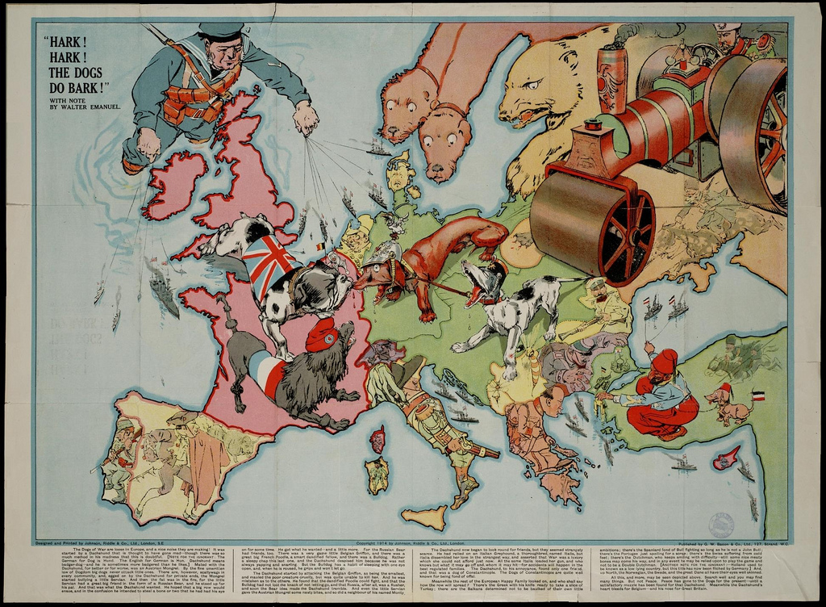
L: A British satirical map of Europe in 1914

http://historiana.eu/collection/satirical-maps

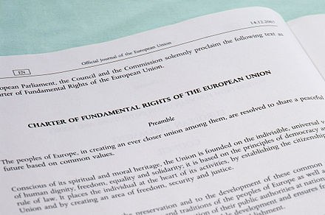
M: Charter of Fundamental Right of the European Union
https://upload.wikimedia.org/wikipedia/commons/thumb/d/d9/01CFREU-Preamble-crop.jpg/440px-01CFREU-Preamble-crop.jpg

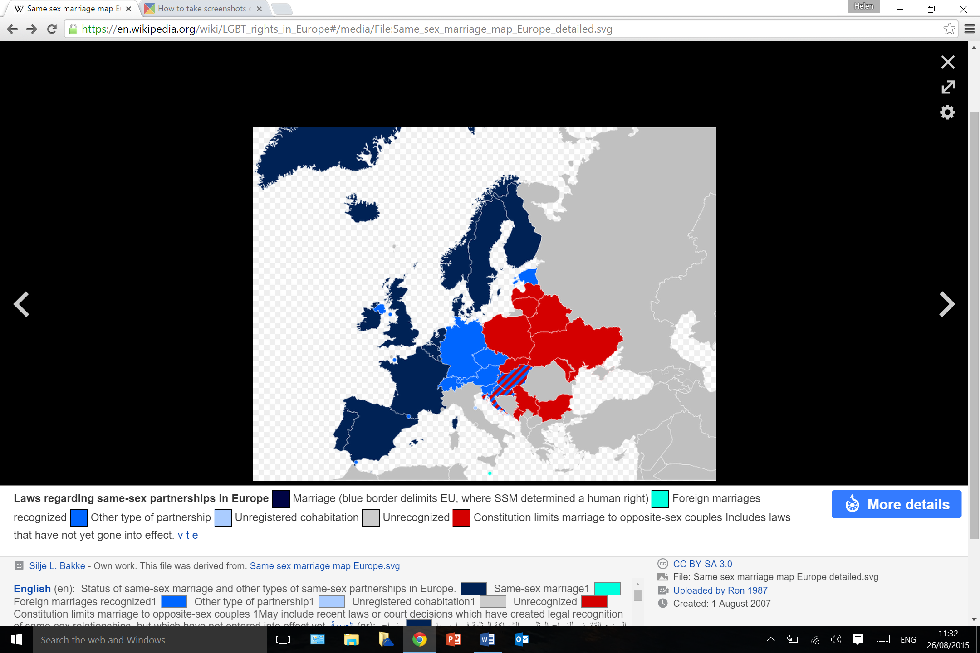
N: Gay marriage rights in the EU, 2015

"Same sex marriage map Europe detailed" by Silje L. Bakke - Own work. This file was derived from: Same sex marriage map Europe.svg. Licensed under CC BY-SA 3.0 via Commons - https://commons.wikimedia.org/wiki/File:Same_sex_marriage_map_Europe_detailed.svg#/media/File:Same_sex_marriage_map_Europe_detailed.svg

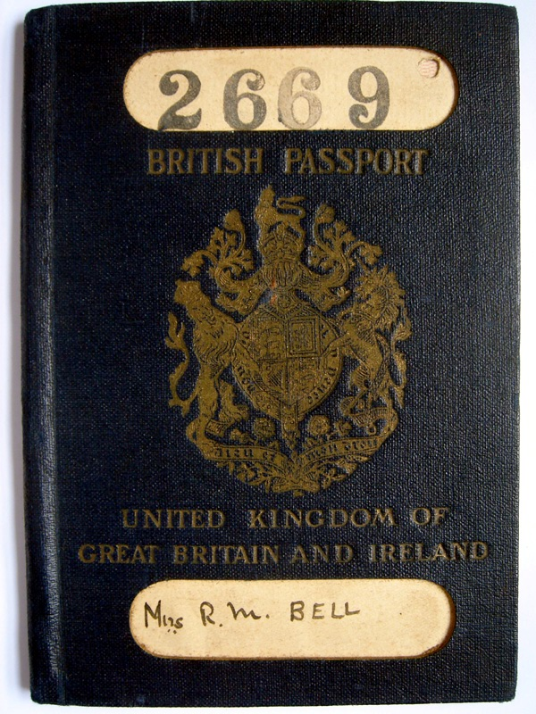

O: A British passport from before the days of the EU
https://upload.wikimedia.org/wikipedia/commons/4/4e/UK_passport_1924.JPG

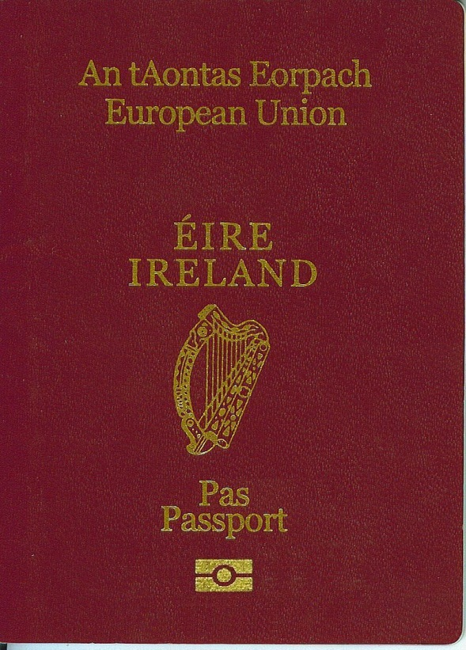

P: An Irish passport from 2000
https://upload.wikimedia.org/wikipedia/commons/thumb/d/d7/Eirepas.JPG/550px-Eirepas.JPG

